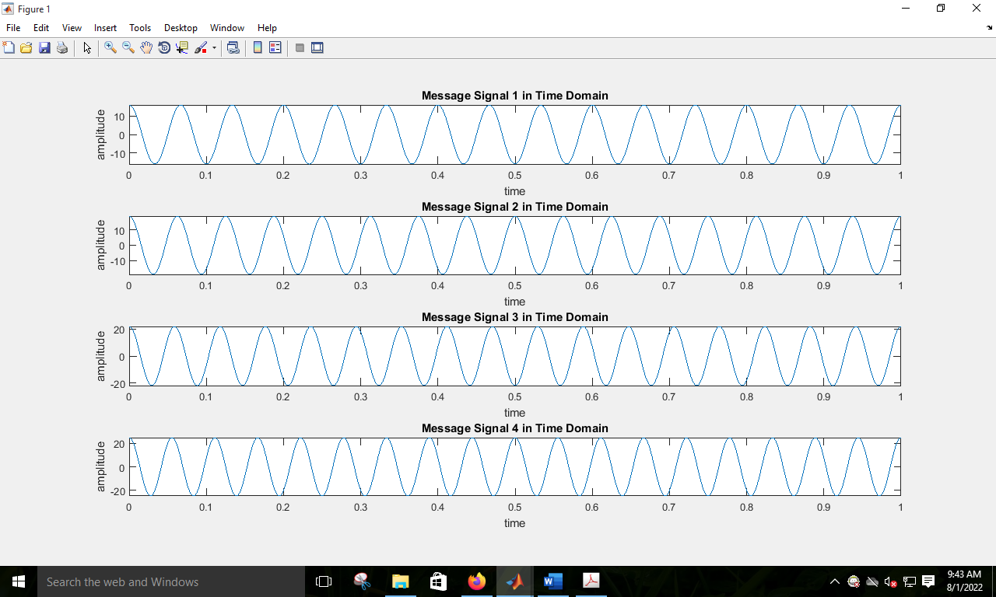

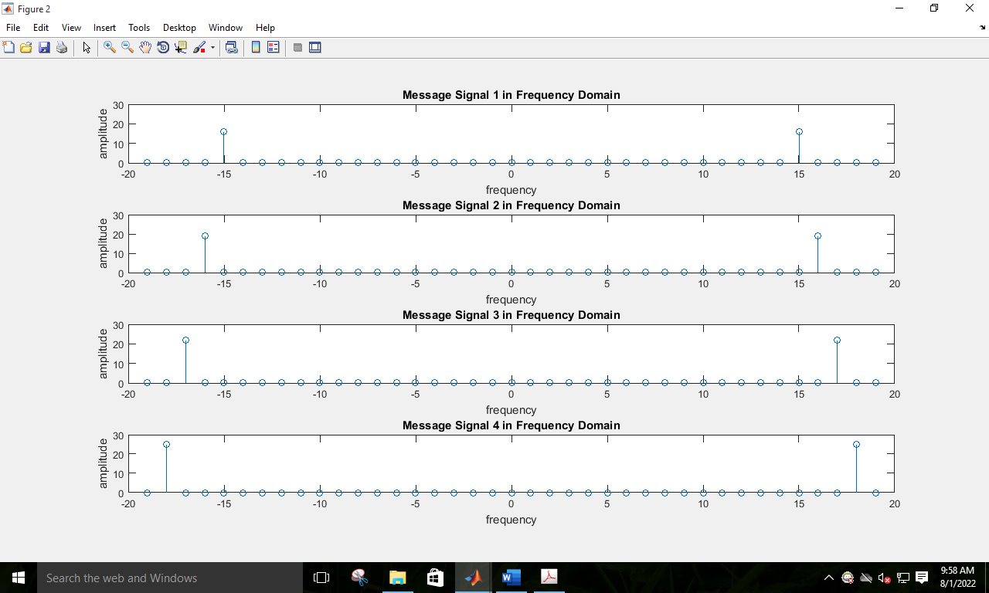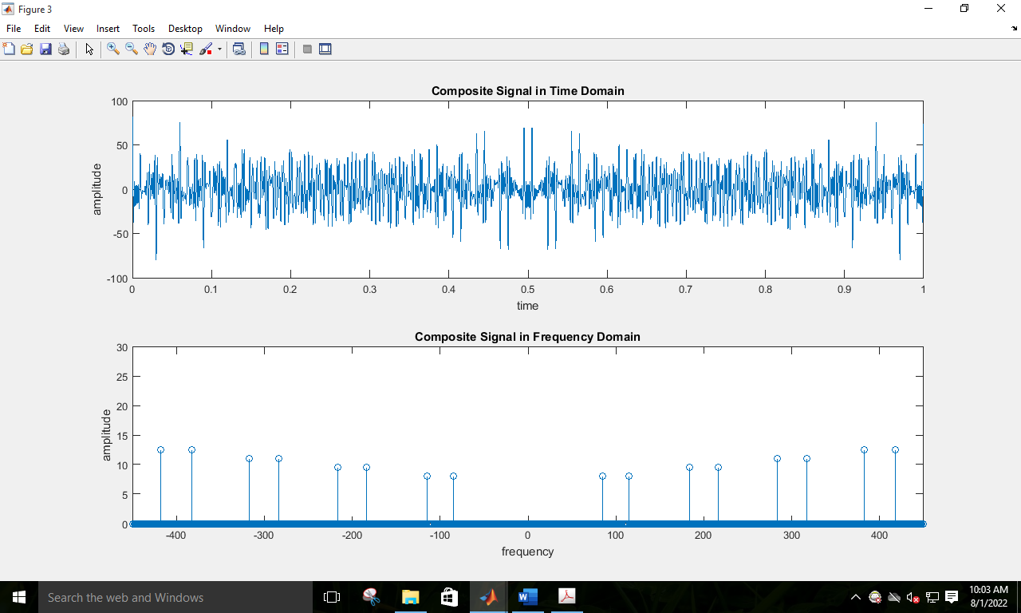

clc

clear all

close all

fs = 4001; %Sampling Frequency

t = 0:1/fs:1-1/fs;

Am1 = 16; %Amplitude of First Message Signal

fm1 = 15; %Frequency of First Message Signal

m1 = Am1\*cos(2\*pi\*fm1\*t); % First Message Signal

Am2 = 19; %Amplitude of Second Message Signal

fm2 = 16; %Frequency of Second Message Signal

m2 = Am2\*cos(2\*pi\*fm2\*t); % Second Message Signal

Am3 =22; %Amplitude of Third Message Signal

fm3 = 17; %Frequency of Third Message Signal

m3 = Am3\*cos(2\*pi\*fm3\*t); % Third Message Signal

Am4 = 25; %Amplitude of Third Message Signal

fm4 = 18; %Frequency of Third Message Signal

m4 = Am4\*cos(2\*pi\*fm4\*t); % Third Message Signal

Cm1 = 1; %Amplitude of First Carrier Signal

fc1 = 100; %Frequency of First Carrier Signal

c1 = Cm1\*cos(2\*pi\*fc1\*t); % First Carrier Signal

Cm2 = 1; %Amplitude of Second Carrier Signal

fc2 = 200; %Frequency of Second Carrier Signal

c2 = Cm2\*cos(2\*pi\*fc2\*t); % Second Carrier Signal

Cm3 = 1; %Amplitude of Third Carrier Signal

fc3 = 300; %Frequency of Third Carrier Signal

c3 = Cm3\*cos(2\*pi\*fc3\*t); % Third Carrier Signal

Cm4 = 1; %Amplitude of Third Carrier Signal

fc4 = 400; %Frequency of Third Carrier Signal

c4 = Cm4\*cos(2\*pi\*fc4\*t); % Third Carrier Signal

x = (m1).\*c1+(m2).\*c2+(m3).\*c3+(m4).\*c4;

figure

subplot(4,1,1)

plot(t,m1)

xlabel('time')

ylabel('amplitude')

title('Message Signal 1 in Time Domain')

ylim([-Am1 Am1])

subplot(4,1,2)

plot(t,m2)

xlabel('time')

ylabel('amplitude')

title('Message Signal 2 in Time Domain')

ylim([-Am2 Am2])

subplot(4,1,3)

plot(t,m3)

xlabel('time')

ylabel('amplitude')

title('Message Signal 3 in Time Domain')

ylim([-Am3 Am3])

subplot(4,1,4)

plot(t,m4)

xlabel('time')

ylabel('amplitude')

title('Message Signal 4 in Time Domain')

ylim([-Am4 Am4])

M1 = abs(fftshift(fft(m1)))/(fs/2); %Fourier Transformation of m1

M2 = abs(fftshift(fft(m2)))/(fs/2); %Fourier Transformation of m2

M3 = abs(fftshift(fft(m3)))/(fs/2); %Fourier Transformation of m3

M4 = abs(fftshift(fft(m4)))/(fs/2);

X = abs(fftshift(fft(x)))/(fs/2); %Fourier Transformation of x

f = fs/2\*linspace(-1,1,fs);

figure

subplot(4,1,1)

stem(f,M1)

xlabel('frequency')

ylabel('amplitude')

title('Message Signal 1 in Frequency Domain')

axis([-20 20 0 30])

subplot(4,1,2)

stem(f,M2)

xlabel('frequency')

ylabel('amplitude')

title('Message Signal 2 in Frequency Domain')

axis([-20 20 0 30])

subplot(4,1,3)

stem(f,M3)

xlabel('frequency')

ylabel('amplitude')

title('Message Signal 3 in Frequency Domain')

axis([-20 20 0 30])

subplot(4,1,4)

stem(f,M4)

xlabel('frequency')

ylabel('amplitude')

title('Message Signal 4 in Frequency Domain')

axis([-20 20 0 30])

figure

subplot(2,1,1)

plot(t,x)

xlabel('time')

ylabel('amplitude')

title('Composite Signal in Time Domain')

subplot(2,1,2)

stem(f,X)

xlabel('frequency')

ylabel('amplitude')

title('Composite Signal in Frequency Domain')

axis([-450 450 0 30])

[num1, den1] = butter(5, [(fc1-fm1-5)/(fs/2),(fc1+fm1+5)/(fs/2)]);% range=80-120

%Butterworth Filter Window Determining for Bandpass Filter

bpf1 = filter(num1,den1,x); %Filtering is done here

[num2, den2] = butter(5, [(fc2-fm2-4)/(fs/2),(fc2+fm2+4)/(fs/2)]);% range=180-220

%Butterworth Filter Window Determining for Bandpass Filter

bpf2 = filter(num2,den2,x); %Filtering is done here

[num3, den3] = butter(5, [(fc3-fm3-8)/(fs/2),(fc3+fm3+8)/(fs/2)]);% range=275-325

%Butterworth Filter Window Determining for Bandpass Filter

bpf3 = filter(num3,den3,x); %Filtering is done here

[num4, den4] = butter(5, [(fc4-fm4-12)/(fs/2),(fc4+fm4+12)/(fs/2)]);% range=370-430

%Butterworth Filter Window Determining for Bandpass Filter

bpf4 = filter(num4,den4,x); %Filtering is done here

z1 = 2\*bpf1.\*c1;

z2 = 2\*bpf2.\*c2;

z3 = 2\*bpf3.\*c3;

z4 = 2\*bpf4.\*c4;

[num4, den4] = butter(5, (fm1+5)/(fs/2)); %Low pass filter is made here %20hz

rec1 = filter(num4,den4,z1); %Filtering is done here

[num5, den5] = butter(5, (fm2+6)/(fs/2)); %Low pass filter is made here

rec2 = filter(num5,den5,z2); %Filtering is done here

[num6, den6] = butter(5, (fm3+7)/(fs/2)); %Low pass filter is made here

rec3 = filter(num6,den6,z3); %Filtering is done here

[num7, den7] = butter(5, (fm4+8)/(fs/2)); %Low pass filter is made here

rec4 = filter(num7,den7,z4); %Filtering is done here

figure

subplot(4,1,1)

plot(t,rec1)

xlabel('time')

ylabel('amplitude')

title('received signal 1 in time domain')

ylim([-Am1 Am1])

subplot(4,1,2)

plot(t,rec2)

xlabel('time')

ylabel('amplitude')

title('received signal 2 in time domain')

ylim([-Am2 Am2])

subplot(4,1,3)

plot(t,rec3)

xlabel('time')

ylabel('amplitude')

title('received signal 3 in time domain')

ylim([-Am3 Am3])

subplot(4,1,4)

plot(t,rec4)

xlabel('time')

ylabel('amplitude')

title('received signal 4 in time domain')

ylim([-Am4 Am4])

R1 = abs(fftshift(fft(rec1)))/(fs/2); %Fourier Transformation is done here

R2 = abs(fftshift(fft(rec2)))/(fs/2); %Fourier Transformation is done here

R3 = abs(fftshift(fft(rec3)))/(fs/2); %Fourier Transformation is done here

R4 = abs(fftshift(fft(rec4)))/(fs/2); %Fourier Transformation is done here

figure

subplot(4,1,1)

stem(f,R1)

xlabel('frequency')

ylabel('amplitude')

title('received signal 1 in frequency domain')

xlim([-20 20])

subplot(4,1,2)

stem(f,R2)

xlabel('frequency')

ylabel('amplitude')

title('received signal 2 in frequency domain')

xlim([-20 20])

subplot(4,1,3)

stem(f,R3)

xlabel('frequency')

ylabel('amplitude')

title('received signal 3 in frequency domain')

xlim([-20 20])

subplot(4,1,4)

stem(f,R4)

xlabel('frequency')

ylabel('amplitude')

title('received signal 3 in frequency domain')

xlim([-20 20])